**IoT-Driven, Cloud-Connected Automated Medicine Dispenser with Web-Based Interface for Enhanced Healthcare**

**Abstract:**

Utilizing a dependable and user-friendly platform, this project presents an automated medicine dispensing system that is cloud-enabled and IoT-based, improving patient safety and medication management. Through the integration of important technologies including RFID, ESP32, and Arduino Mega, this system uses RFID cards to identify specific users, enabling customized medicine administration. Users and caregivers can choose drugs, adjust dosages, and plan distribution times using a Python-based web interface thanks to the Wi-Fi-enabled ESP32 module, which guarantees safe cloud connectivity. When the system is configured, user input is processed and stored on the cloud server, allowing for real-time monitoring and, if necessary, intervention by caregivers and healthcare professionals. The Arduino Mega, which is controlled by the ESP32 upon receiving dispensing instructions, uses servo motors to precisely and precisely release the prescribed dosage of medication at the appointed time. In order to improve adherence and responsibility, automated reminders remind users to take their medications on time and notify caretakers of any missed doses. This system, which is cost-effective and scalable, offers a safe, automated solution that reduces human error, enhances adherence, and can be used in a variety of healthcare settings, such as clinics, senior care facilities, and home care.

**Keywords:** Automated Medicine Dispensing System, Cloud-enabled, IoT-based, Patient Safety, Medication Management, RFID, ESP32, Arduino Mega, Python-based Web Interface and Real-time Monitoring.

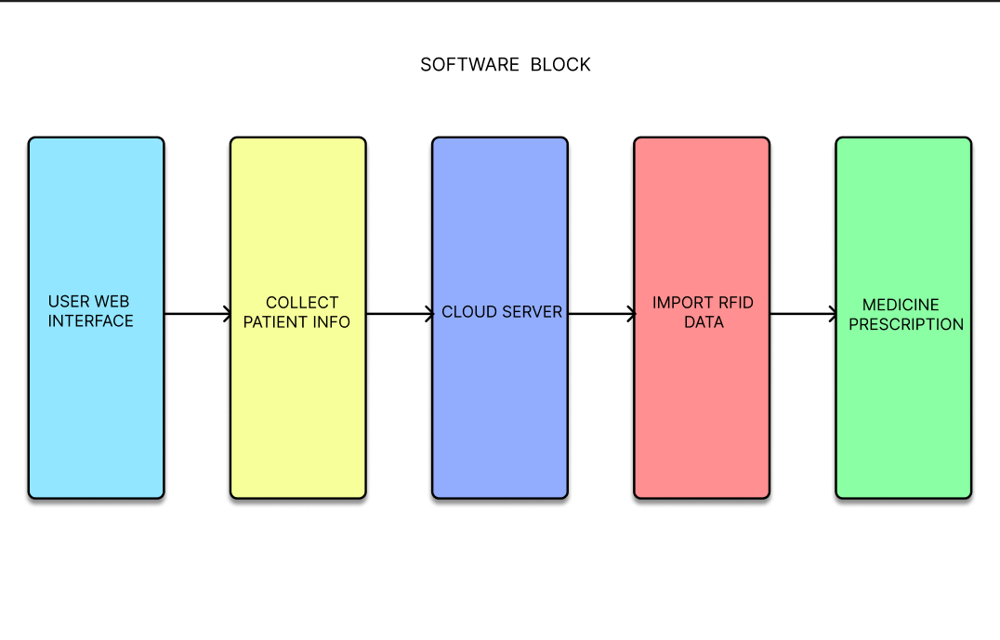**Block Diagram:**

Arduino Mega

Power Supply

ESP32

RFID

LCD

SERVO Motor

SERVO Motor

**Working Principle:**

The proposed automated medicine dispensing system integrates RFID, ESP32, and Arduino Mega technologies to streamline medication management. After securely logging in using an RFID card, users can access a Python-based, cloud-hosted web application to select medications, set dosages, and schedule dispensing times. The ESP32 module, connected to the cloud server, processes and securely stores these inputs, enabling real-time monitoring by caregivers and healthcare professionals. Once dispensing instructions are verified, the ESP32 communicates with the Arduino Mega to control servo motors, releasing the precise dosage at the scheduled time. RFID provides an added security layer, ensuring only authorized access to the system. Automated reminders help users stay on track with their medications, while notifications alert caregivers of missed doses. With its modular and scalable design, this system can adapt to various healthcare environments, reducing the need for direct intervention and enhancing patient safety and adherence to prescribed treatment plans.

**Existing System**

Existing medication dispensing systems range greatly in complexity, from basic pill organizers to intricate automated devices, yet they frequently lack key features. Patients or caregivers can monitor dosages with simple manual pill organizers and locked cabinets, but they are not automated, necessitating frequent human supervision and increasing the possibility of errors or missed doses. Advanced home dispensers are usually independent devices without cloud integration, which limits remote control and monitoring. They can release preset dosages at predetermined periods and occasionally connect to mobile apps for notifications. Automated dispensing machines, such as Pyxis or Omnicell, are fully connected with healthcare information systems in pharmacies and hospitals; nevertheless, their high cost and complexity limit their use to professional settings, rendering them unsuitable for everyday household use. Remote tracking is possible with new IoT-enabled dispensers that have cloud connectivity, but these systems are frequently costly, complicated, and not entirely tailored for household settings, necessitating technical expertise to use efficiently. Widespread adoption is hampered by the present systems' high prices and lack of real-time interaction, especially for elderly or chronically ill patients who require prescription care at home. This emphasizes the need for an inexpensive, cloud-integrated Internet of Things solution that bridges the gap for both clinical and home healthcare applications by enabling real-time, web-based control and monitoring.

**Limitations of Existing Systems**

* High-end, cloud-connected automated medicine dispensers are often expensive, making them less accessible for general users, especially in home healthcare.
* Many dispensing systems require specific technical knowledge or training to operate, reducing usability for elderly or disabled patients.
* Existing cloud-enabled or IoT-based systems still lack advanced real-time control or interaction capabilities, particularly in home-use scenarios.

**Proposed System**

Comparing the suggested system to current options, the cloud-enabled, Internet of Things-based automated medicine dispenser greatly improves patient safety and medication management. It offers an accessible, safe, and adaptable solution by combining RFID, Arduino Mega, and ESP32 technologies. Users may easily choose drugs, adjust dosages, and schedule times by using an RFID card to access the system via a web interface hosted in the cloud and powered by Python. This device, in contrast to many standalone dispensers, securely processes and maintains data in the cloud, allowing healthcare providers and caregivers to remotely and in real time monitor medication adherence. After verification, the Arduino Mega, which regulates servo motors that discharge precise dosages, coordinates with the cloud server via the ESP32. The majority of simple pill organizers and independent dispensers lack the extra security that RFID-based authentication offers by guaranteeing that only authorized individuals can access the medication. With the ability to notify caretakers if a dose is missed, the system's real-time warnings and reminders assist users in sticking to their schedules. This functionality goes beyond the basic notification capabilities seen in many modern gadgets. This modular system is appropriate for home healthcare, senior care, and clinics since it is made to be easily integrated and scaled. Compared to conventional dispensers, it lowers human error, increases adherence, and improves patient safety by automating dispensing, enabling remote cloud monitoring, and guaranteeing secure access management.

**Advantages of Proposed Systems**

* Real-time connectivity allows users or caregivers to manage and monitor medication dispensing from anywhere, improving flexibility.
* The system ensures precise dosages, minimizing errors and supporting medication adherence.
* Dispensing events are logged on the cloud for remote monitoring and adherence analysis by healthcare providers.